**Additional information more specifically relating to work and performance levels during the pandemic**.

**Adults Social Care**

**Hospital Discharge**

**Overview and Lancashire & South Cumbria Project**

Shortly after the start of the pandemic, a new National Hospital Discharge Operating Policy was introduced which placed a firm emphasis on people only remaining in hospital if they have a defined clinical need to do so. Everyone else not meeting the agreed 'criteria to reside' must be urgently discharged. Initially the discharge window was 2 - 4 hours, and following the learning during the first 6 months this was revised to reflect some of the challenges in preparing people for and facilitating discharge. So, from the 1st September 2020 the desired discharge timescale was within the same day.

The new policy sets out changes in roles and functions of various staff and organisations involved in the discharge process including hospitals, upper tier councils and social care providers. People are now no longer assessed whilst in hospital but are discharged onto 'discharge to assess/recover pathways' ranging from home with no support right up to 24hr care in a Care Home. The clear aim is to achieve 95% of people returning directly home and the policy is underpinned by a national Discharge Support Fund of £588m, which ends on the 31st March 2021.

LCC in partnership with the NHS locally already had a range of intermediate care services in place. These include the 'Home First' service which provides immediate care support for people who need it in their own home for up to 5 days, enabling them to recover from their hospital stay before having a fuller assessment to determine the most appropriate onward service to meet their needs. For many people the initial support is enough to help them recover to be able to manage independently again, some people need short term support for example from the Reablement service and a smaller number of people will need longer term homecare support.

In Lancashire & South Cumbria, whilst the implementation of the national Hospital Discharge Policy was undertaken across all the hospitals at significant pace to meet the requirements and ensure rapid discharges could take place, this resulted in a lack of consistent processes and agreements across the Integrated Care System (ICS). This is now being picked up through an ICS Hospital Discharge project which aims to bring a level of consistent practice across the ICS underpinned by a Lancashire & South Cumbria standard operating procedure that aligns to the national policy. This work will ensure that there is a consistent process and service offer to all ICS residents, no matter which hospital the person is discharged from. The project is jointly led by the County Council and the NHS on behalf of all ICS partners, and is supported by a Hospital Discharge Executive group with the executive leads from each Integrated Care Partnership (ICP), project officers from the Midland and Lancashire Commissioning Support Unit, an ICS operational group plus ICP steering groups to ensure local implementation and delivery of the ICS operating process.

Some of the key achievements of the ICS project so far include:

* An agreed set of discharge principles that place the person at the centre of the process
* The establishment of the ICS Executive group and the ICP steering groups to ensure consistent implementation
* Bespoke Emergency Care Improvement Support Team (ECIST)/LGA facilitated workshops for Therapy staff, Social Care staff and a data interpretation session
* The development of Designated Settings for people who need 24/7 support, are COVID positive and needing to leave hospital
* Agreed set of discharge pathway definitions that will bring consistency of discharge options and reporting across the ICS

**Lancashire County Council Performance**

In responding to the new national policy, the LCC Hospital Discharge teams moved quickly to base themselves into the community to be able to undertake the majority of assessments there rather than on hospital wards, after people have been discharged. Some assessments such as Mental Capacity Assessments, Best Interests Decisions and some safeguarding work still needs to be undertaken by social workers with people whilst they are in hospital, but in the main our hospital discharge staff now undertake assessments with people in their own home, a rehabilitation unit or in a CQC registered care home.

Initial challenges included undertaking many assessments with people remotely, with the aim of reducing transmission of the virus. Creative ways to conduct assessments have been used including use of video calls. The role of care home providers in particular has become even more critical in supporting people to be assessed and to participate in their assessment through digital technology.

An additional challenge was that in the first few months of the pandemic and the national need to free up hospital beds quickly, we saw more people being transferred into care homes. Work has been underway across the second half of the year to assess all of those people and understand their ongoing needs, and where their needs can be met at home this has been facilitated. At times, there have been significant challenges in finding care home placements for people who need them on discharge when there's been reduced care home capacity due to COVID outbreaks or where people's needs have been very complex and more difficult to support.

The work through the pandemic whilst it has been hugely challenging, has also enabled improved collaborative working with the NHS, and through having to find more creative ways to work closely together to best meet people's need when being discharged from hospital this has seen communication and relationships strengthened. Adult Social Care has also continued to develop and implement new ways of working, bringing together social care teams to further improve our response and meet the demands of 2 hour and same day discharges. During the pandemic we have rolled out our Intermediate Care Allocation Teams (ICAT) into Fylde and Wyre and West Lancashire so that we now have these in place across the county. The teams have made greater use of services such as reablement, AgeUK 'Take Home and Settle' and crisis support and have also forged closer relationships with district councils in supporting people who are homeless or have other housing needs and need to be discharged.

The hospital discharge work has remained high across the last 10 months, and the social care teams have worked hard with their NHS colleagues to increase the number of people able to return directly home through Home First. Overall, the teams have been involved with 10,364 discharges since 1st March 2020 – 11th February 2021. At the same time, we have seen discharge delays significantly reduce meaning that many more people have been able to be discharged as soon as possible after they no longer have a clinical need to stay there.

The graph below shows the increase in 'Home First' referrals (Nb doesn't include East Lancashire data as not available when graph produced):

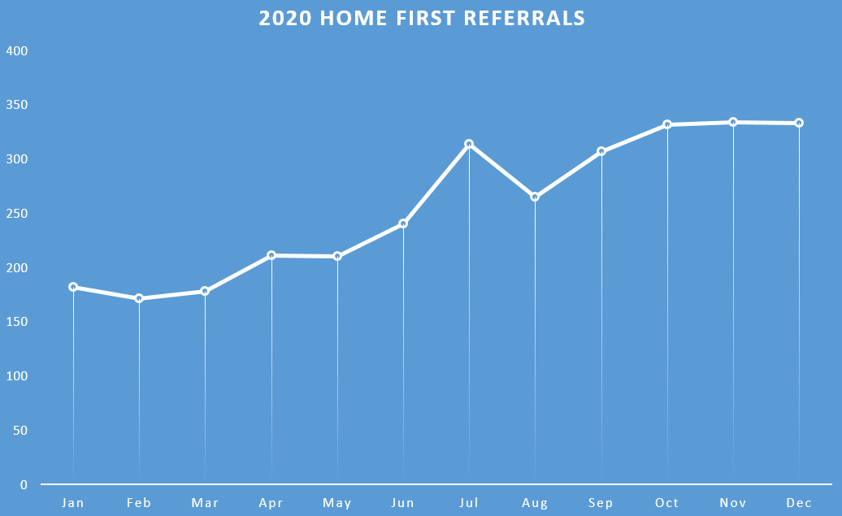

The most common outcomes for people once their needs are assessed after coming home via 'Home First' are: 40% with reablement and 23% had no care required.

**Designated Settings**

The national Adult Social Care Plan published in September 2020 set out the requirement for designated beds in care homes to enable the discharge from hospital of people who are COVID positive and need a care home placement. Designated settings have to meet a defined set of requirements including a separate unit, a separate set of staff and enhanced infection control measures. People are discharged into a designated setting to complete the necessary 14-day isolation before returning to their existing care home or transferring to a discharge to assess care home bed. These interim beds help avoid the transmission of the virus in care homes following discharge from hospital.

LCC in partnership with the NHS, CQC and care home providers have opened up 58 designated beds across Lancashire. Whilst the beds continue to be an important service to support hospital discharge of people who are COVID positive, the usage of the beds has remained steady but lower than anticipated.

Data from commencement of first designated setting on 26th November 2020 to 11th February 2021:

|  |  |
| --- | --- |
| **Mapleford**  **No. Admissions**: 35 (31 LCC)  **Avg Length of Stay**: 11 days | **Oaklands**  **No. Admissions**: 19 (14 LCC)  **Avg Length of Stay**: 11 days |
| **Swansea Terrace**  **No. Admissions**: 22 (22 LCC)  **Avg Length of Stay**: 10 days | **Manse**  **No. Admissions**: 9 (7 LCC)  **Avg Length of Stay**: 8 days |
| **Courtfield**  **No. Admissions**: 5 (4 LCC)  **Avg Length of Stay**: 9 days | **OVERALL**  **Total Admissions:** 90  **Total Discharges:** 72  **Average Length of Stay:** 9.8 days |

Following discharge from a designated setting, the onward destinations for people are:

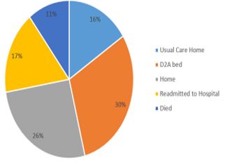

**Winter**

This year, winter planning required Adult Social Care to take account not just of typical winter pressures, but also the added challenges that were evident across the social care sector from the first wave of the COVID-19 pandemic, alongside ensuring readiness for further waves and spikes. Combined with those challenges, the NHS has also been restoring services that had been paused through the first 6 months of the pandemic which has an impact on social care demand. Ensuring the stability of the social care market and sufficiency of care is of paramount importance and was a critical part of this winter plan.

Although there have been a number of challenges across winter, many elements of our winter plan have been successfully implemented and have supported us to meet people's needs though the last few months whether that's been through discharging more people more quickly from hospital, or enabling them to remain in their own home.

An additional 1800 crisis hours have been implemented each week, including 'Crisis Plus' hours which are available to support people 24/7 for up to 7 days in their own home which supports people who may have previously needed to go into a care home for a short period of time. Additional reablement hours have been provided to ensure that there is capacity in the service to enable people to move on from Crisis and 'Home First' hours, supporting continuous flow out of the hospitals as well as avoiding unnecessary admissions. Significant work has continued across the winter months in supporting the care market, particularly the care homes, through the challenges of COVID outbreaks and staffing shortages due to illness and the need to isolate.

Staffing recruitment has been a challenge, both for qualified social workers and occupational therapists in the council and for care staff across the providers. This has however improved in recent weeks. The fact that hospital discharge delays have remained significantly lower than previous winters, and people are not waiting for urgent support in their own homes demonstrates the success of our winter plan, despite some of the challenges of sustained high levels of COVID-19 across Lancashire, continuing incidents of COVID outbreaks across the care market and staff recruitment.

**Summary of Winter Plan Implementation**

* 1800 hours per week implemented across Home First and Crisis hours
* £795,600 invested over a 6 month period
* 60 winter posts, with 18 (30%) filled (as at 11th February, 2021)
* Recruitment activity has included social media advertising, job sites such as Indeed and Greater Jobs, press releases, engagement with universities. This work is continuing.
* It has been difficult to recruit to social worker and occupational therapy posts across the county
* Reasons for recruitment difficulties include: fixed term contracts, need for job security, uncertain times leading to individuals remaining in current jobs, professional qualifications required.

**Lancashire Temporary Staffing Agency (LTSA) 'Join our care team in Lancashire' recruitment**

In April 2020, faced with the pandemic and its implications on frontline care staff, the Human Resources Service set up an internal staffing agency – Lancashire Temporary Staffing Agency (LTSA). This has successfully built capacity for care workers, easing the burden on care providers’ management teams to ensure they can focus on increasingly demanding frontline activities.

The initial recruitment campaign was focussed on meeting demand for residential care roles. This campaign received 1454 expressions of interest, 738 of those received within the first two weeks.

The LTSA currently has 160 carers on their books and has 64 active assignments in place in 32 residential care homes for older people (16 LCC and 16 private providers).

Built at speed, the LTSA and the recruitment campaign was launched with the help of corporate communications colleagues and, in order to support the LTSA, staff from other services that had been stood down as a result of the pandemic were deployed.

Initially, the LTSA conducted telephone interviews with candidates. However, after receiving feedback that this process was too time-consuming and not getting carers on the ground quickly enough, interviews were stopped and instead the LTSA now deploy candidates into care homes on a paid work-shadowing basis, whilst pre-employment/safeguarding checks were completed. Candidates complete paid online training throughout this shadowing period. Although not all candidates have completed full DBS checks in place before entering a home, they are accompanied by an experienced carer throughout their shadowing placement, therefore eliminating safeguarding risk.

Initially, LCC-run care homes assisted the LTSA with the provision of work-shadowing opportunities for new recruits, and as the programme went from strength to strength, LTSA gained the support of private care providers in this process too.

Once candidates are trained and cleared, they are put into the LTSA pool and deployed to care homes as needed. In practice, many candidates remain working in the homes where they underwent work-shadowing, but are sometimes deployed elsewhere following demand, whilst adhering to infection control requirements.

The care capacity tracker, where a team of LCC staff call providers on a daily basis to assess capacity, is used to alert the LTSA when a provider may need support.

Following the success of this initial recruitment campaign, the LTSA has used the same model to recruit for cleaners and caterers within care homes, drivers and passenger assistants, and staff for the community testing programme. Each recruitment campaign is tailored to the skillset required.

**Children's Social Care**

|  |  |  |  |  |  |  |  |  |
| --- | --- | --- | --- | --- | --- | --- | --- | --- |
| **Performance Indicator** | **Frequency** | **Directorate** | **Good is** | **2019/20 Performance** | **Q1** | **Q2** | **Latest Performance** | **Getting to Good Target** |
| Percentage of assessments completed during the year which took over 45 days | Monthly | Education and Children's Services | High | 88.4% | 94.8%  (June 2020) | 92.6%  (Sept 2020) | 92.5%  (Dec 2020) | 90% |
| Number and rate (per 10k) of children with a child protection plan | Monthly | Education and Children's Services | - | 836/33.5 (Mar 2020) | 809/32.4 (June 2020) | 777/31.0 (Sept 2020) | 678/27.0 (Dec 2020) | - |
| Percentage of children with a repeat child protection plan over last 12 months | Monthly | Education and Children's Services | Low | 7.0% (Mar 2020) | 7.0% (June 2020) | 7.1% (Sept 2020) | 5.7% (Dec 2020) | 7% |
| Percentage of child protection plan visits up to date | Monthly | Education and Children's Services | High | 89% (Mar 2020) | 92% (June 2020) | 87% (Sept 2020) | 84% (Dec 2020) | 90% |
| Rate of Children Looked After (CLA) number/per 10,000 | Monthly | Education and Children's Services | - | 2,095/83.9 (Mar 2020) | 2,118/84.8 (June 2020) | 2,131/84.9 (Sept 2020) | 2,106/83.9 (Dec 2020) | - |
| Percentage of CLA up to date health assessments | Monthly | Education and Children's Services | High | 80% (Mar 2020) | 90.5% (June 2020) | 87.5% (Sept 2020) | 91.9% (Dec 2020) | 90% |
| Percentage of CLA up to date dental assessments | Monthly | Education and Children's Services | High | 69.9% (Mar 2020) | 79.2% (June 2020) | 68.9% (Sept 2020) | 51% (Dec 2020) | 90% |
| Percentage of CLA up to date visits | Monthly | Education and Children's Services | High | 91.9% (Mar 2020) | 94% (June 2020) | 92.7% (Sept 2020) | 90.9% (Dec 2020) | 90% |

**Children's Social Care Highlights.** Despite the ongoing pandemic pressures, the performance of the majority of Children's social care headline indicators remain stable and above target. The proportion of assessments completed in time remains consistently above target and above all comparator averages (England 82.7% and North West 83.7%). The number and rate of Child Protection Plans (CPP) continue to decrease significantly with children only being made subject to a plan or remaining on a plan where absolutely necessary. The repeat CPP rate has reduced to 5.7%, the lowest rate seen since July 2018 (5.6%). The Children Looked after (CLA) rate remained stable throughout the year with up to date visits remaining high and above target throughout the year.

The proportion of CP visits up to date has reduced over the last few months of 2020 to 84% at the end of December, however more recent data from the end of January 2021 suggests an improvement to 94%. Although the proportion of CLA with an up to date health assessments has remained relatively stable and on target during the pandemic the proportion of CLA with an up to date dental assessments has dropped significantly through the second half of 2020, to 51% at the end of December 2020.This trend is mirrored in other Local Authorities and is mainly due to the impact of the pandemic on the availability of dental clinics and the work of dentists.

**Committees Reports available on work being undertaken across the authority in relation to COVID-19.**

**Internal Scrutiny:**

* Redefining Lancashire – Our approach to recovery – 10 July 2020 <https://council.lancashire.gov.uk/ieDecisionDetails.aspx?ID=18836>
* Highways Service Covid-19 Response – 10 July 2020 <https://council.lancashire.gov.uk/ieDecisionDetails.aspx?ID=18837>
* Lancashire's Response to Covid-19 – 11 September 2020 <https://council.lancashire.gov.uk/ieDecisionDetails.aspx?ID=18838>
* Update – Lancashire's Response to Covid-19 – 22 January 2021 <https://council.lancashire.gov.uk/ieListDocuments.aspx?CId=120&MId=10401>

(Presentation at item 4)

**External:**

* Universal Credit and the Pandemic – LCC Welfare Rights Service –  17 November 2020

<https://council.lancashire.gov.uk/ieDecisionDetails.aspx?ID=18734>

**Health Scrutiny:**

* NHS Test and Trace and Mass Testing – 15 December 2020 <https://council.lancashire.gov.uk/ieDecisionDetails.aspx?ID=18705>

**Education & Children's Services Scrutiny**

* Preparing for an Increase in Demand for Children's Social Care – 14 October 2020 <https://council.lancashire.gov.uk/ieDecisionDetails.aspx?ID=18840>
* Emotional Wellbeing and Mental Health of Children and Young People – 16 December 2020 <https://council.lancashire.gov.uk/ieDecisionDetails.aspx?ID=18842>

**Education Scrutiny** (former committee – now part ofEducation & Children's Services Scrutiny – see above):

* Response to Covid-19 pandemic in Lancashire – 7 July 2020 <https://council.lancashire.gov.uk/ieDecisionDetails.aspx?ID=18834>